**CPSC 2221-01 - 3nd MILESTONE**

**INSTRUCTOR HAZRA IMRAN**

**GROUP 3:**

**ARUNDEEP CHOHAN 100201711**

**MING-WEI CHU 100263266**

**TOMAS GONZALEZ ORTEGA 100266942**

**RENE MUELLER ROGER 100257606**

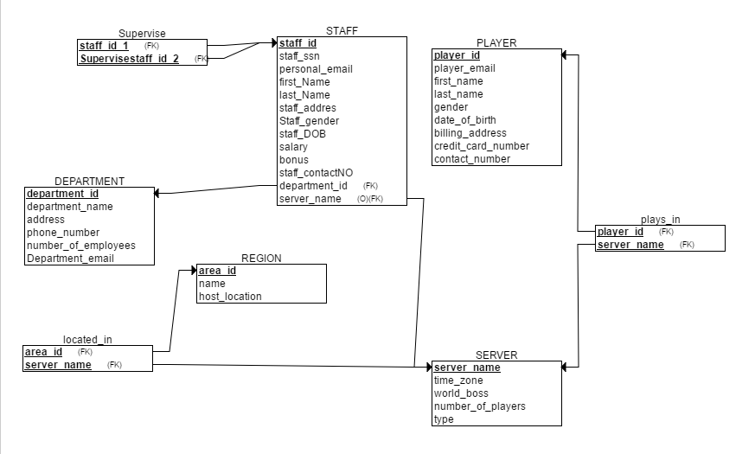

**SUPERVIESE** (Staff_Id_1, SupervisesStaff_Id_2)

Staff_Id_1 - Sid1

SupervisesStaff_Id_2 - Ssid2

**STAFF** (Staff_ssn, Staff_Personal_email , First_name, Last_name, Staff_address, staff_gender, Staff_DOB, Salary, bonus, Staff_ContactNo, Department_id, Position)

Staff_ssn - Sssn

Staff_Personal_email - Pmail

First_name - Fname

Last_name - Lname

Staff_address - Sadr

Staff_gender - Sgen

Staff_DOB - Sbday

Salary - Slr

Bonus - Bns

Staff_ContactNo - ScNo

Department_id - Did

Position - Pstn

**STAFF FDs**

Sssn → Pmail, Fname, Lname, Sdress, Sgen, Sbday, Slr, ScNo, Did

Pmail → Fname, Lname, Sdress, ScNo

Pstn → Bns, Slr

**PLAYER** (Player_Id, Player_email, First_name, Last_name, Gender, Date_of_Birth, Player_address, Contact_number)

Player_Id - Pid

Player_email - Pmail

First_name - Fname

Last_name - Lname

Gender - Gnd

Date_of_Birth - DoB

Player_address - Padr

Contact_number - Cnum

**PLAYER FDs**

Pid → Pmail, Fname, Lname, Gnd, DoB, Padr, Cnum

Pmail → Fname, Lname, Gnd, DoB, Padr

**DEPARTMENT**(Department_ID, Department_name, Department_Address, Department_phone_Number, Number_of_Employees, Department_email)

Department_ID - Did

Department_name - Dname

Department_Address - Dadr

Department_phone_number - Dpnum

Number_of_Employees - NumEmp

Department_email - Dmail

**DEPARTMENT FDs**

Did → Dname, Dadr, Dpnum, NumEmp, Dmail

**REGION**(Area_id, Region_Name, Host_Location)

Area_id - Aid

Region_Name - Rname

Host_Location - Hloc

**PLAYS_IN**(Player_ID, *Server_name*)

Player_ID - Pid

Server_name - Sname

**LOCATED_IN**(Area_id, Server_name)

Area_id - Aid

Server_name - Sname

**SERVER**(Server_name, Time_Zone, World_boss, Number_of_Players, Type)

Server_name - Sname

Time_Zone - Tzon

World_boss - Wboss

Number_of_Players - Nplay

Type - Tp

**Normalization process**

The 1NF was make sure we didn’t have any multivalue in the tables.

Out 2NF was eliminate any Composite attributes (instead of have FullName we have FirstName and LastName for Players and Staff), as well as removing partial FD’s by using only one primary key for each table.

For Normalization process to 3NF, we broke down our tables into smaller tables by taking transitive FD’s and created a new table based on the attributes in the transitive FD. We did this for the Player and Staff table, but not for the Department table since there were too many redundant FD’s.

ERD IN 1NF and 2NF



ERD IN 3NF

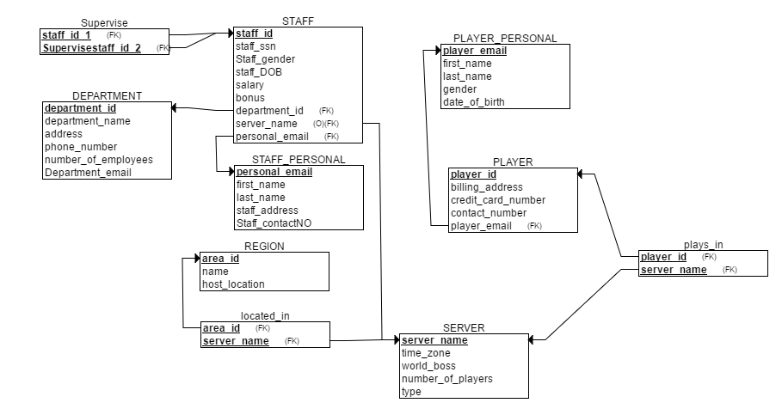

Tables

1. Supervise
   1. FK - Staff_Id_1
   2. FK - Supervisestaff_id_2
2. Department
   1. PK - department_id
3. Staff
   1. PK - staff_id
   2. FK - department_id
   3. FK - server_name
   4. FK - personal_email
4. Region
   1. PK - area_id
5. Located_in
   1. FK - area_id
   2. FK - server_name
6. Server
   1. PK - server_name
7. Player_Personal
   1. PK - Player_email
8. Player
   1. PK - Player_ID
   2. FK - player_email
9. Staff_Personal
   1. PK - personal_email
10. Plays_In
    1. FK - player_id
    2. FK - server_name